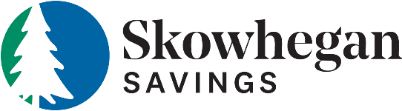

Skowhegan Savings Bank Retail Banking Products & Services
Consumer Deposit Services
E-Tegrity Checking
Integrity Checking
Integrity Plus Checking
Integrity Prime Checking
Integrity Savings
Integrity Money Market
Integrity Plus Money Market
Health Savings Account
Club Account
Certificate of Deposit (91 Day; 6 months; 1,2,3 & 5 Year)
IRA (30 Day; 2,3 & 5 Year)

Consumer Lending
Residential Mortgage Loans-Fixed & Adjustable Rate (Primary, Second Home, Seasonal, 1-4 Family, Land)
Residential Construction Loans
Home Equity Loan-Fixed Rate/Fixed Term
Home Equity Line of Credit (HELOC)
Personal Loans (Vehicle, Recreational Vehicle, Unsecured & Deposit Secured)

Consumer Electronic Services
Online Banking
Mobile Banking
Mobile Deposit
BillPay
Open Anywhere (Online Account Opening)
Electronic Documents
Telephone Banking
Bank to Bank Transfers

Consumer Miscellaneous Services
VISA Credit Card
MasterCard Debit Cards
ATM Card
Safe Deposit Boxes
Direct Deposit

Business Deposit Services
Business Checking
Business Plus Checking
Community Checking
Municipal Checking
Sweep Account
Business Savings

Business Green Products
Business Green Checking
Business Green Savings

Business Lending
Commercial & Industrial Loans
Lines of Credit
Commercial Real Estate Loans
Commercial Equipment Financing
Agency Loan Partnerships

Business Electronic Services
Online Business Banking
BillPay
Mobile Banking
Mobile Deposit
ACH Processing
Remote Deposit
Positive Pay
Telephone Banking
Online Wires

Business Miscellaneous Services
Payroll Services
Merchant Services
Outgoing Bank Wire
Business VISA

Misc Services available to Consumer & Business
Money Orders
Treasurer Checks
Notary Public
Signature Guarantee
Wire Transfers
Foreign Currency Exchange

